We believe that:
All children are unique  Children are capable and competent  Children are at the centre of all we do | Children learn through doing  Productive partnerships between home and school are essential | Educators employ evidence based practice  Educators work as collaborative teams
What does this mean for children?  - Decision making across the school is based on children’s best interest.  - Children are the focus of all relationships.  - Children’s voices are actively sought and responded to.  - A child’s sense of belonging and wellbeing are important parts of their learning.  - Children have opportunities to interact with siblings and other significant people at school.  - Children feel valued and enjoy coming to school.  - Smooth, facilitated transitions are planned between birth to year 2 programs and beyond.  - Buddy experiences allow classes/groups within the school to come together for learning opportunities and celebrations.  - A range of meaningful opportunities exist for families to engage and interact with their children’s learning.  - All children have access to the whole school.  - Children have opportunities to become familiar with all faces and spaces and develop a sense of ownership of the school.  - Mutual respect is encouraged with children and educators being called by their first name.  - Children regularly observe educators and families conversing in meaningful and respectful ways. | What does this mean for educators?  - Educators have access to knowledge about all services offered within the school.  - Educators communicate with families openly and regularly.  - Educators respectfully share relevant information to support children.  - Educators use inclusive terminology relevant to all programs, for example ‘educators’ instead of ‘staff’.  - Educators have knowledge of and relationships with external services, for example Tuggeranong Child and Family Centre.  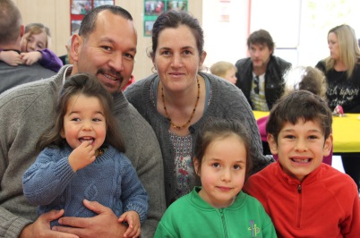  - Meetings encourage team work and professional discussion.  - Educators are encouraged to collaborate and support one another.  - Educators have opportunities to broaden their skills by taking on various roles across the school.  - The school works in partnership with local services and other schools to facilitate links for families. | What does this mean for families?  - Families have the opportunity to develop purposeful relationships with educators.  - Families receive support as needed in response to our commitment to a ‘no wrong doors’ approach.  - Opportunities are available for all professionals to come together to discuss children’s wellbeing and learning.  - Families have access to a range of services and programs within the school.  - Families have opportunities to be involved in a variety of working teams: KidsMatter, Green Team, Fresh Taste, GEMS and School Board.  - Families have opportunities to be involved in a variety of Community programs: Playgroup, Move and Groove, Backyard Rangers, Family Breakfast and Paint and Play.  - Families have opportunities to attend a range of celebrations.  - Families can expect a timely response to communication.  - The family room is a child friendly area that is dedicated for family or community use.  - Families are encouraged to make connections with other families.  - Families are supported when children are transitioning between programs and to other schools.
What are the outcomes of integrated service delivery at IPECS?
- Children have a strong sense of wellbeing; they cooperate and work collaboratively with others.
- Children are effective communicators; they convey and construct messages with purpose and confidence.
- Children have a strong sense of identity; they belong to a secure and supportive school community.
- Children are confident and involved learners; they adapt and transfer learning from one context to another.
- Children are connected to and contribute to their world; they show an understanding of the reciprocal rights and responsibilities necessary to be part of a community.

