Safe and Supportive Learning Environments at Isabella Plains Early Childhood School

We believe that:
All children are unique  Children are capable and competent  Children are at the centre of all we do | Children learn through doing  Productive partnerships between home and school are essential | Educators employ evidence based practice  Educators work as collaborative teams
What does this mean for children?  - Children have the vocabulary to name their feelings  - Children experience a sense of place and belonging  - Children have strategies to regulate their feelings and emotions  - Children’s work is relevant and purposeful and reflective of current learning eg. displays are rotated throughout the year.  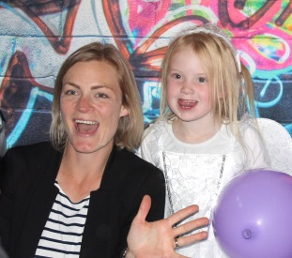  - Children have choice and the opportunity to follow their own interests during indoor and outdoor learning  - children have a voice and co-construct their learning  - children engage in learning that is developmentally appropriate  - children and educators collaboratively develop class agreements that help support safe and healthy learning environments  - All children can access quiet spaces when required  - Children have an understanding of their place in the world and the place of the people around them  - Children have relationships with multiple trusted adults | What does this mean for educators?  - we are responsive to children’s needs  - educators use an evidence based approach to design learning environments  - we engage in restorative practices with children  - educators invest time in building respectful relationships  - provide intensive, individualised support for children that require additional support in an appropriate and timely manner  - staff select resources that promote inclusion and diversity and ensure all children can access those resources  - educators take the initiative to develop relationships with families and value that partnership  - intentionally develop children’s social and emotional skills  - we collaboratively develop and explicitly teach class agreements  - we are trained in Kidsmatter  - we keep data and evidence on children’s social, emotional and physical development  - we follow directorate policy and procedure in relation to responding to children’s wellbeing | What does this mean for families?  - All families are treated with respect and dignity.  - Families are part of an inclusive and engaged school community  - Families are supported to access a wide range of services  - Families have access to spaces, workshops and events that further develop their knowledge of children's social and emotional development  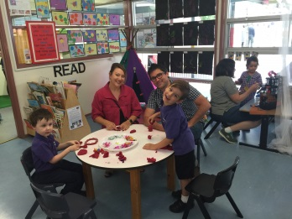  - Sharing of information is reciprocal between families and educators to best support the child.  - Parents are partners in teaching and learning  - Communication with families is reciprocal and undertaken in a timely manner and employs a range of communication such as phone, face to face and email  - Confidentiality is maintained.  - Families are confident that their children are being nurtured, cared for and are thriving while at school
What are the outcomes of safe and supportive learning environments at IPECS?
- positive and engaging environments
- children develop social skills and resilience to thrive and lead fulfilling, productive and responsible lives
- increased communication and ownerships of processes and procedures for all school community
- increased participation and engagement with the school community involving parents
- maximise student outcomes through meeting individual needs
- promoting positive mental health and wellbeing for all children and their families

